Data Pipeline for E-Commerce Order Fulfilment and Supply Chain Management

Contents
CHAPTER ONE: INTRODUCTION 3
1.1 Introduction 3
1.2 Problem Statement 3
1.3 Background and Motivation 3
1.4 Aim and Objectives 4
1.5 Significance of the Project 4
1.6 Project Scope 4
1.8 Project Timeline 5
1.9 Conclusion 5

CHAPTER ONE: INTRODUCTION

Introduction
The rapid growth of e-commerce has transformed how goods and services are bought, sold, and delivered across the world (Laudon and Traver, 2023). In Southern Africa, logistics companies play a critical role in enabling cross-border and local e-commerce by managing order fulfilment, warehousing, and last-mile delivery(World Bank, 2022a).As transaction volumes increase, so does the complexity of handling large amounts of operational data generated from orders, inventory, transportation, and customer interactions (Chopra and Meindl, 2021). This growth in data requires organizations to adopt more advanced data management and processing approaches to remain competitive (Waller & Fawcett, 2019).In modern organizations, data-driven decision making is essential for improving efficiency, reducing costs, and enhancing customer satisfaction (Provost and Fawcett, 2013). This has increased the demand for robust data engineering solutions, particularly data pipelines that can ingest, process, and deliver reliable data for analytics and operational use (Kleppmann, 2017).This project focuses on designing and implementing a data engineering pipeline for e-commerce order fulfilment and supply chain operations. The aim is to support timely insights, operational visibility, and informed decision making in logistics environments(Kimball and Ross, 2013).

Problem Statement
Despite the availability of large volumes of operational data in e-commerce logistics, many organizations struggle to integrate, process, and effectively utilize this data(Batini et al., 2016). In companies, information related to orders, shipments, delivery times, warehouse operations, and customer feedback is often generated from multiple systems and stored in different formats (Hazen et al., 2014).As a result, reporting is frequently delayed and real-time visibility into order fulfilment processes is limited (Kache and Seuring, 2017). Data inconsistencies and poor data quality further undermine operational decision making and reduce confidence in analytical outputs. (Batini and Scannapieco, 2016)The lack of integrated data makes it difficult to track overall supply chain performance and identify operational bottlenecks (Chopra and Meindl, 2021). In addition, reliance on manual data handling increases operational risks, processing delays, and the likelihood of human error (Redman, 2018).Without a well-designed data pipeline, transforming raw logistics data into accurate, timely, and actionable insights becomes challenging (Kleppmann, 2017). This ultimately hinders efficient supply chain management, scalability, and customer service performance in e-commerce logistics operations (Waller and Fawcett, 2019).

Background and Motivation
The rapid expansion of e-commerce in Southern Africa has significantly increased the demand for logistics systems that are reliable, transparent, and capable of supporting fast order fulfilment across both urban and remote regions (Laudon and Traver, 2023). As online retail activity grows, logistics operations are under increasing pressure to handle higher transaction volumes while maintaining service quality and cost efficiency (World Bank, 2022a).
Operational efficiency in logistics organizations plays a critical role in determining customer satisfaction, delivery reliability, and overall profitability (Chopra and Meindl, 2021) . Inefficiencies in data handling, order tracking, and warehouse coordination can lead to delayed deliveries, increased costs, and reduced trust in e-commerce platforms (Kache and Seuring, 2017).
As students of data science specializing in data engineering, there is strong motivation to apply theoretical concepts such as data integration, ETL processes, and pipeline orchestration to real-world operational challenges (Provost and Fawcett, 2013). Practical, industry-focused projects provide an opportunity to bridge the gap between academic knowledge and professional skills required in modern data-driven organizations (Waller and Fawcett, 2019).
The logistics and supply chain sector is particularly data-intensive, generating large volumes of structured and semi-structured data from order management systems, transportation platforms, warehouse management systems, and customer feedback channels (Hazen et al., 2014). However, this data is often fragmented across multiple systems, limiting its usefulness for analytics and operational decision making without effective data engineering solutions (Batini and Scannapieco, 2016).
This project is motivated by the need to address core data integration, transformation, and pipeline orchestration challenges commonly encountered in logistics environments (Kleppmann, 2017). By designing and implementing a robust data pipeline, the project demonstrates how raw operational data can be transformed into consistent, high-quality datasets suitable for real-time monitoring, performance analysis, and strategic planning (Kimball and Ross, 2013).
Beyond its technical contribution, the project provides valuable insights into how data engineering supports supply chain visibility, risk reduction, and process optimization (Redman, 2018). Improved data availability and quality enable organizations to identify bottlenecks, forecast demand, and respond proactively to operational disruptions (Chopra and Meindl, 2021).
From an academic and professional perspective, this project serves as a capstone demonstration of applied data engineering competencies, including data modelling, pipeline automation, and quality management (Batini and Scannapieco, 2016). The practical nature of the project enhances portfolio readiness and prepares students for roles in data engineering, analytics, and digital transformation initiatives within the logistics and e-commerce sectors (Waller and Fawcett, 2019).

Aim and Objectives
Aim: To build a cloud-based data pipeline that consolidates e-commerce fulfillment data for end-to-end supply chain visibility and analytical reporting.

Objectives

- Ingest and integrate data from multiple e-commerce and logistics sources into a unified pipeline.
- Automate ETL processes to enable scheduled and repeatable data workflows.
- Store processed data in a centralized repository optimized for analytics and reporting.
- Provide analytics-ready datasets to monitor order fulfilment and supply chain performance.
- Visualize operational performance using interactive dashboards highlighting trends and bottlenecks.

Significance of the Project
The pipeline will provide data-driven insights to reduce operational costs, improve delivery reliability, enhance customer communication with real time tracking and support strategic decisions regarding warehouse and fleet management.

Project Scope
- Focus on the domestic e-commerce parcel delivery process within South Africa.
- Development using simulated or anonymized datasets representing operational data (orders, shipments, tracking events, warehouse logs).
- Building a functional prototype pipeline on a major cloud platform (AWS, GCP, or Azure).
- Creating analytics dashboards for historical and current performance
- The focus remains on data engineering and pipeline automation rather than advanced predictive modeling.

1.7 Project Timeline
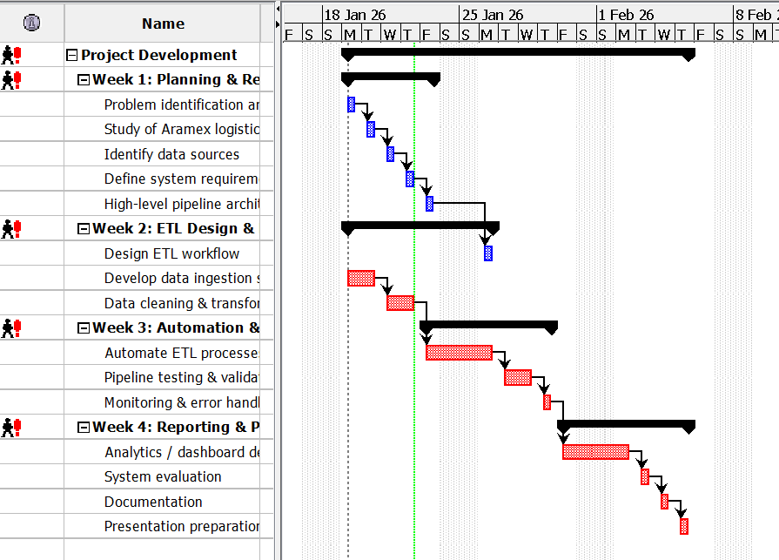

1.8 Conclusion
This chapter introduced the study by outlining the background, problem statement, objectives, and significance of the project. By focusing on an e-commerce order fulfilment and supply chain data pipeline, the project aims to bridge theoretical knowledge and practical data engineering skills, preparing the student for industrial attachment and real-world challenges.

CHAPTER TWO: LITERATURE REVIEW
2.1 Introduction
This chapter reviews existing academic and industry literature related to data engineering pipelines, e-commerce logistics and supply chain data management. The purpose of the literature review is to establish a theoretical and practical foundation for the project by examining how previous studies have addressed data integration, ETL processes and analytics in logistics and e-commerce environments. The chapter also identifies limitations in current research and practice particularly within developing regions such as Southern Africa thereby justifying the need for the proposed study.

2.2 Review Methodology
The literature review was conducted using peer reviewed academic journals, textbooks, conference proceedings and industry reports related to data engineering, supply chain management and e-commerce logistics. Emphasis was placed on recent literature (2013–2024) to ensure relevance to modern cloud based and data driven environments. Industry reports from organizations such as the World Bank were also reviewed to provide regional context for logistics operations in Southern Africa.
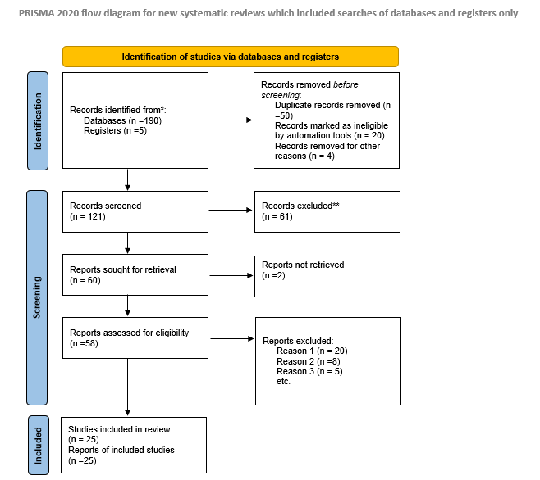

2.3 Data Engineering and Data Pipelines
Previous literature defines data engineering as the discipline responsible for building reliable systems that move data from operational sources to analytical platforms. Traditional batch based ETL pipelines have been widely used for reporting but research shows that they struggle with the scale and speed of modern e-commerce data (Kimball and Ross, 2013).
More recent studies advocate for automated and scalable pipeline architectures that reduce latency and improve data consistency (Provost and Fawcett, 2013). However, many of these studies remain conceptual or cloud-architecture focused.
This study builds on existing work by implementing a practical end-to-end data pipeline that automates ingestion, transformation and storage of logistics data demonstrating how theoretical pipeline concepts can be applied in a real operational context.
2.4 E-commerce Logistics and Supply Chain Data
The literature shows that e-commerce logistics generates large volumes of data across order fulfilment, warehousing, transportation and last-mile delivery (Chopra and Meindl, 2021). This data is typically spread across multiple systems which creates fragmented data environments and limits end-to-end supply chain visibility (Kache and Seuring, 2017).
Although previous studies emphasize the value of data integration and analytics for improving logistics performance (Waller and Fawcett, 2019) most focus on large organizations in developed economies. My proposed study differs by addressing these challenges within a developing country context using realistic logistics data and focusing on integration rather than analytics alone.

2.5 Data Quality and Integration Challenges
Research consistently identifies data quality issues as major barriers to reliable decision making in logistics systems (Batini and Scannapieco, 2016). These problems are often worsened by manual data handling and spreadsheet-based reporting, which increase errors and delays (Redman, 2018).
While the literature recommends automated and standardized ETL processes to address these challenges (Kleppmann, 2017), many studies stop at recommendations. My study directly addresses this gap by implementing automated ETL workflows with built-in data validation to improve data reliability and consistency.

2.6 Cloud-Based Data Pipelines
Existing research shows that cloud platforms enable scalable, cost-effective data pipelines and support fluctuating e-commerce workloads (Waller and Fawcett, 2019). Cloud-based pipelines also allow faster development and easier system maintenance compared to traditional on-premise solutions (Kimball and Ross, 2013).
However, the literature highlights a gap between generic cloud pipeline architectures and practical implementations tailored to specific logistics contexts, especially in developing economies (World Bank, 2022b). This project addresses that gap by designing a cloud-based pipeline specifically for domestic e-commerce parcel delivery, focusing on operational visibility rather than theoretical architecture. Despite these advantages the literature notes a gap between theoretical pipeline architectures.

2.7 Research Gaps
Despite extensive literature on data management and supply chain theory, specific gaps remain, particularly in the Southern African context. First, a contextual implementation gap persists, as much existing literature proposes generic architectures or focuses on global north infrastructures, with limited documented research on implementing cloud-native data pipelines tailored to the operational realities, connectivity challenges, and data maturity levels of logistics firms in the region (World Bank, 2022a). Second, there is an integration-over-modeling gap while many studies acknowledge data fragmentation, their proposed solutions often emphasize technological integration over the practical design of consolidated, business friendly data models that are immediately usable for analytics in logistics. Third, a notable gap exists between theoretical frameworks for data-driven supply chains and practical, end-to-end prototypes that demonstrate the pipeline's tangible value from raw data ingestion to operational dashboards, especially when using accessible cloud technologies.

2.8 Conclusion
This chapter reviewed literature related to data engineering pipelines, e-commerce logistics, data quality and cloud-based analytics. The review established that effective data pipelines are essential for transforming fragmented logistics data into actionable insights. While existing studies provide valuable theoretical foundations, gaps remain in practical, region-specific implementations, particularly within Southern Africa.
The proposed project addresses these gaps by designing and implementing a cloud-based data pipeline for e-commerce order fulfilment and supply chain operations. By focusing on data integration, automation, and analytics readiness, the project contributes both academically and practically to the understanding of how data engineering supports modern logistics environments.

Chapter 3
3.1 Introduction
This chapter outlines the methodological approach and technical framework for designing and implementing the cloud-based data pipeline. The methodology is designed to achieve the project's aim of consolidating e-commerce fulfilment data for enhanced supply chain visibility. It details the structured process for development, justifies the chosen software development lifecycle, and specifies the tools and technologies that will be used to construct a functional, scalable, and automated pipeline prototype.
3.2 Software Development Methodology
The project will employ an Adaptive (Agile) Methodology, specifically incorporating principles from Scrum and Kanban, within a structured systems development lifecycle. This hybrid approach is chosen for its flexibility, iterative nature and focus on delivering incremental value.
Justification
The project will adopt an Adaptive software development methodology drawing on principles from Scrum and Kanban within a structured systems development lifecycle. This hybrid approach supports iterative development, flexibility and continuous delivery of value. It enables core components of the data pipeline to be developed and tested incrementally, reducing integration risks and allowing early identification of issues. Additionally, the methodology accommodates evolving requirements as the dataset and transformation needs become clearer ensuring steady progress through incremental milestones while maintaining effective risk management.

3.3 Tools and Technologies
- Amazon Web Services (AWS)
- AWS Glue / Apache Kafka (MSK)
- SQL (via AWS Glue/ETL Jobs), Python (PySpark)
- Apache Airflow
- Amazon S3 (Data Lake), Amazon Redshift
- Amazon QuickSight / Tableau Public
- Git / GitHub
- AWS CloudFormation / Terraform

3.4 Conclusion
This chapter has defined a pragmatic and industry-aligned methodology for the project. By adopting an adaptive Agile approach, the development process remains flexible and responsive. The selected technology stack, centered on AWS cloud services, provides the necessary managed components to efficiently build, automate, and scale the data pipeline. This methodology and toolset are directly tailored to meet the stated objectives of data integration, ETL automation, centralized storage and analytical delivery forming a solid foundation for the system design and implementation detailed in the next chapter.

